PSG COLLEGE OF TECHNOLOGY, COIMBATORE -4
DEPARTMENT OF APPLIED MATHEMATICS AND COMPUTATIONAL SCIENCES
III M.Sc Data Science - 5th SEMESTER
15XD56 - JAVA PROGRAMMING LAB
PROBLEM SHEET – 6
To demonstrate Java built-in exceptions - Create user defined exceptions and chained exceptions
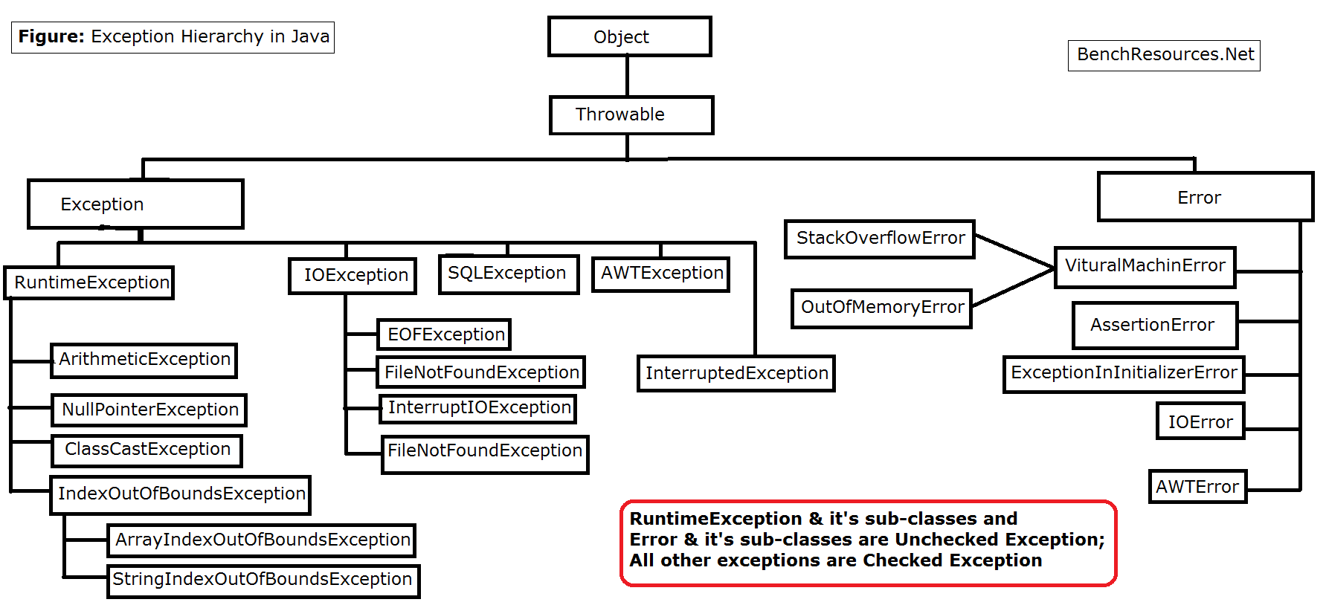
1. The Java program should allow the user to compute sums of integers given in input. The program repeatedly asks the user if he/she wants to calculate a sum; if the answer is yes, then the program takes in input a sequence of integers terminated by a 0, then prints its sum, and asks the same question again. If the answer is no, then the program terminates.
The program as it is written, however, will not even pass compilation, because of uncaught (checked) exceptions. The program should include the suitable try-catch statement(s) so to cope with the following exceptions:
- NumberFormatException: an exception of this kind means that the datum read does not represent an integer. If this occurs, the user should be asked to reenter the datum and continue.
- InputMismatchException:. Also in this case, the user should be asked to reenter the datum and continue.
        - Write a JAVA program which has
a. A Class called Account that creates account with 500Rs minimum balance, a deposit() method to deposit amount, a withdraw() method to withdraw amount and also throws LessBalanceException if an account holder tries to withdraw money which makes the balance become less than 500Rs.
b. A Class called LessBalanceException which returns the statement that says withdraw amount (___Rs) is not valid.
c. A Class which creates 2 accounts, both account deposit money and one account tries to withdraw more money which generates a LessBalanceException take appropriate action for the same.
        - Write a Java program that enters an 8-digit string for a birth date . The first two digits in the string are the month of birth, the next two are the day and the remaining four are the year. The Java program should squeeze out these substrings and display it on the screen. You need to check if the month and day are out of range, and handle the exceptions of Integer.parseInt().
>Suppose the string entered is: 07211979
Then prints:
month of birth: 07
day of birth: 21
year of birth: 1979
>Suppose the string entered is: 06311979
Then prints:
Month 06 only has only 30 days. Try again.
Hint. Use the String class and the method -public String substring(int beginIndex,int endIndex)
        - Create a class Myexception and declare the integer a,b,c inside the class. Store length of the argument in a and get the variable for b. Calculate c=b/a. Print the value of a,b,c. Declare variable d[] = new int [a-2]. The program should give an output of the following form:
Sample input and output:
C:\>java exception8
Enter bvalue:1
java.lang.ArithmeticException:/by zero
C:\>java exception8 3
Enter b value: 4
a = 1
b = 4
b/a = 4
java.lang.NegativeArraySizeException
C:\>java exception8 3 5
Enter b value: 5
a = 2
b = 5
b/a =2
java.lang.ArrayIndexOutOfBoundsException: 42
C:\>java exception8 3 5
Enter b value: t
java.lang.NumberFormatException: for input string : “t”.

5. Calculate reservation totals

Example of Console Output

Welcome to the Reservation Calculator.

Enter the arrival month (1-12): 5
Enter the arrival day (1-31): 16
Enter the arrival year: 2005

Enter the departure month (1-12): 5
Enter the departure day (1-31): 18
Enter the departure year: 2005

Arrival Date: Monday, May 16, 2005
Departure Date: Wednesday, May 18, 2005
Price: $115.00 per night
Total price: $230.00 for 2 nights

Another reservation? (y/n): n
Press any key to continue . . .

- This application calculates the charges for a stay at a hotel based on the arrival and departure dates.
- The application begins by prompting the user for the month, day, and year of the arrival and the departure.
- Next, the application displays the arrival date, the departure date, the room rate, the total price, and the number of nights.
- The main method should handle NumberFormatException if an invalid data for month, day, and year is entered.
- Create three custom exception handlers named MonthOutOfRangeException, DayOutOfRangeException, and YearOutOfRangeException, respectively to handle such exceptions, in addition to NumberFormatException described above.
- Use the GregorianCalendar class to create dates from the int values entered by the user. Then, use the getTime method to convert the GregorianCalendar object to a Date object.

- ArrayStoreException is thrown whenever we are storing something in an array. If we store wrong type object into an array then this will be thrown. Write a java code to generate ArrayStoreException

